**Week6 React HandsOn**

**5. ReactJS-HOL**

**Objectives**

* Understanding the need for styling react component
* Working with CSS Module and inline styles

Folder Structure

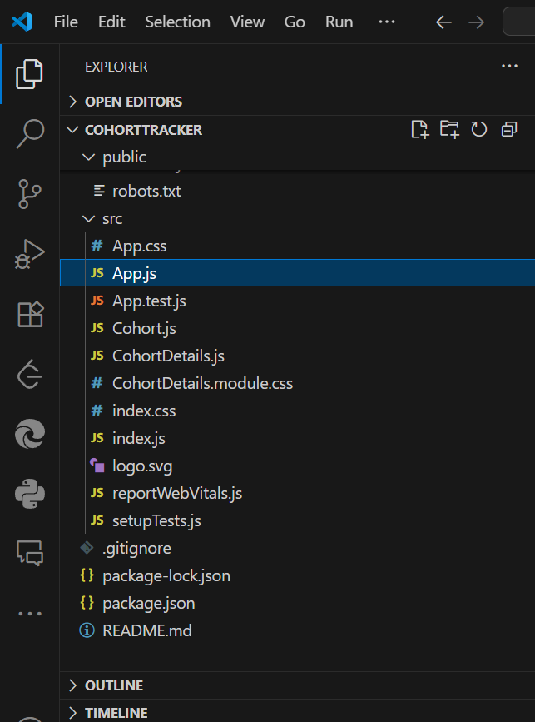

**App.js**

// App.js

import React from 'react';

import './App.css';

import { CohortsData } from './Cohort';

import CohortDetails from './CohortDetails';

function App() {

  return (

  <div>

    <h1>Cohorts Details</h1>

    {CohortsData.map(cohort => <CohortDetails cohort={cohort}/>)}

  </div>

  );

}

export default App;

**Cohort.js**

class Cohort {

    constructor(cohortCode,

        startDate,

        technology,

        trainerName,

        coachName,

        currentStatus) {

        this.cohortCode = cohortCode;

        this.coachName = coachName;

        this.trainerName = trainerName;

        this.technology = technology;

        this.startDate = startDate;

        this.currentStatus = currentStatus;

    }

}

const CohortsData =[

    new Cohort('INTADMDF10','22-Feb-2022', '.NET FSD', 'Jojo Jose','Aathma', 'Scheduled'),

    new Cohort('ADM21JF014','10-Sep-2021', 'Java FSD', 'Elisa Smith','Apoorv', 'Ongoing'),

    new Cohort('CDBJF21025','24-Dec-2021', 'Java FSD', 'John Doe','Aathma', 'Ongoing'),

];

export {Cohort, CohortsData};

**CohortDetails.js**

import React from 'react';

import styles from './CohortDetails.module.css';

function CohortDetails(props) {

    const statusColor = props.cohort.currentStatus.toLowerCase() === 'ongoing' ? 'green' : 'blue';

    return (

        <div className={styles.box}>

            <h3 style={{ color: statusColor }}>

                {props.cohort.cohortCode} - <span>{props.cohort.technology}</span>

            </h3>

            <dl>

                <dt>Started On</dt>

                <dd>{props.cohort.startDate}</dd>

                <dt>Current Status</dt>

                <dd>{props.cohort.currentStatus}</dd>

                <dt>Coach</dt>

                <dd>{props.cohort.coachName}</dd>

                <dt>Trainer</dt>

                <dd>{props.cohort.trainerName}</dd>

            </dl>

        </div>

    );

}

export default CohortDetails;

**CohortDetails.module.css**

.box {

  width: 300px;

  display: inline-block;

  margin: 10px;

  padding: 10px 20px;

  border: 1px solid black;

  border-radius: 10px;

}

dt {

  font-weight: 500;

}

**Output:**

PS C:\Users\umaya\Desktop\-Cognizant-Nurture-4.0-practice\Week6\cohorttracker> npm start

> cohortstracker@0.1.0 start

> react-scripts start

Browserslist: caniuse-lite is outdated. Please run:

npx browserslist@latest --update-db

Why you should do it regularly: https://github.com/browserslist/browserslist#browsers-data-updating

(node:3532) [DEP_WEBPACK_DEV_SERVER_ON_AFTER_SETUP_MIDDLEWARE] DeprecationWarning: 'onAfterSetupMiddleware' option is deprecated. Please use the 'setupMiddlewares' option.

(Use `node --trace-deprecation ...` to show where the warning was created)

(node:3532) [DEP_WEBPACK_DEV_SERVER_ON_BEFORE_SETUP_MIDDLEWARE] DeprecationWarning: 'onBeforeSetupMiddleware' option is deprecated. Please use the 'setupMiddlewares' option.

Starting the development server...

Compiled successfully!

You can now view cohortstracker in the browser.

Local: http://localhost:3000

On Your Network: http://192.168.140.50:3000

Note that the development build is not optimized.

To create a production build, use npm run build.

assets by path static/js/*.js 1.5 MiB

asset static/js/bundle.js 1.49 MiB [emitted] (name: main) 1 related asset

asset static/js/node_modules_web-vitals_dist_web-vitals_js.chunk.js 6.93 KiB [emitted] 1 related asset

asset index.html 1.67 KiB [emitted]

asset asset-manifest.json 458 bytes [emitted]

cached modules 1.37 MiB [cached] 110 modules

runtime modules 31.3 KiB 15 modules

webpack 5.68.0 compiled successfully in 4257 ms

